- 8 ounces flour  - 0.2 ounce fast active yeast  - 1 generous pinch salt  - 7 oz butter (soft)  - Sugar  - 0.75 cup water | 1 | Prepare the yeast: heat the water (110 Fahrenheit), dissolve 1 teaspoon of sugar inside, then add the yeast. Let it proof 10 minutes.  Measure the flour and place in a mixer bowl (hook), add the salt on one side and the proofed yeast on the other and mix, then add the melted butter. Knead 2 min slow and 5 more minutes medium. Transfer to a lightly oiled bowl, cover with plastic and let proof for 30 minutes and up to an hour. | • 8 ounces flour  • 0.2 ounce fast active yeast  • 1 pinch salt  • 1 tsp sugar  • 1 oz melted butter  • 0.75 cup water | «Kouign Amann stands for butter cake, so don’t be shy with the butter...»
 | 2 | Flatten the butter between 2 sheets of parchment paper (must be 0.2 inches thick). Refrigerate. | • 6 oz butter
 | 3 | Roll out the dough on parchment paper to the size of a piece of Legal paper. Place the butter in the center and fold back the two sides. Roll out to the size of Legal paper. Fold in 3. Cover with plastic and refrigerate for 30 minutes. Repeat twice (3 times total). Roll out again, sprinkle with sugar, fold. Roll again and cut in stripes. Place as spirals in buttered muffin tins cover and let rise 30 minutes. preheat the oven at 360°. | • sugar
 | 4 | Sprinkle with sugar and bake for 30 minutes. | • sugar
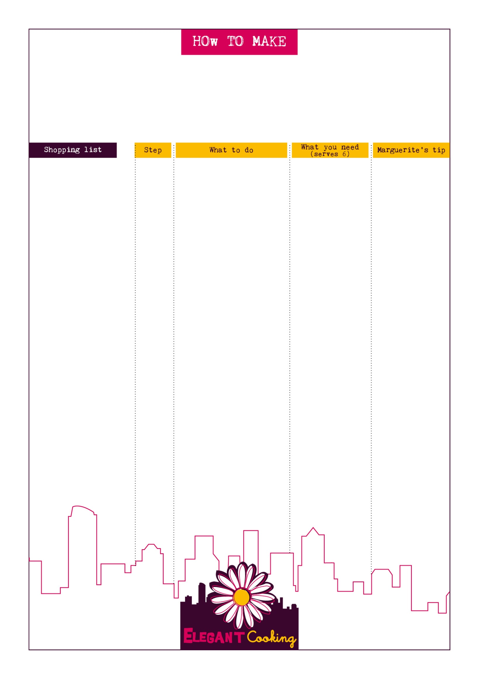
Kouign Amann

